Laporan Praktikum Pemrograman Berbasis Framework

Nama : Daffa Tahta Akbar

Nim : 1741720152

1. Install redux

* *create-react-app contact-redux*

1. Install form

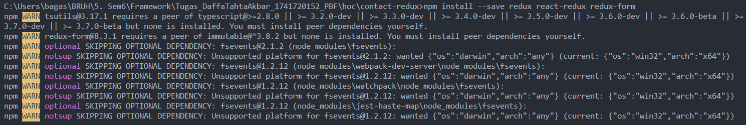

1. Mengubah index.html dalam folder public

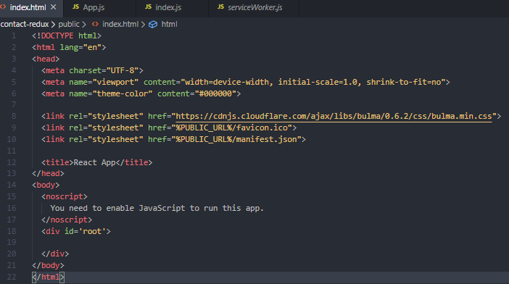

1. Mengubah App.js pada folder /src/App.js

import React, { Component } from "react";

import { reduxForm, Field } from "redux-form";

import logo from "./logo.svg";

import "./App.css";

let SignInForm = props => {

const { handleSubmit } = props;

return (

<form onSubmit={handleSubmit} className="form">

<div className="field">

<div className="control">

<Field

name="firstName"

component={renderField}

type="text"

label="First Name"

/>

</div>

</div>

<div className="field">

<div className="control">

<Field

name="lastName"

component={renderField}

type="text"

label="Last Name"

/>

</div>

</div>

<div className="field">

<div className="control">

<Field

name="email"

component={renderField}

type="email"

label="Email Address"

/>

</div>

</div>

<div className="field">

<div className="control">

<Field name="age" component={renderField} type="number" label="Age" />

</div>

</div>

<div className="field">

<div className="control">

<label className="label">Proficiency</label>

<div className="select">

<Field className="input" name="proficiency" component="select">

<option />

<option value="beginner">Beginner Dev</option>

<option value="intermediate">Intermediate Dev</option>

<option value="expert">Expert Dev</option>

</Field>

</div>

</div>

</div>

<div className="field">

<div className="control">

<label className="label">Gender</label>

<label className="radio">

<Field name="gender" component="input" type="radio" value="male" />{" "}

Male

</label>

<label className="radio">

<Field

name="gender"

component="input"

type="radio"

value="female"

/>{" "}

Female

</label>

</div>

</div>

<div className="field">

<div className="control">

<label className="checkbox">

<Field

name="saveDetails"

id="saveDetails"

component="input"

type="checkbox"

/>

Save Details

</label>

</div>

</div>

<div className="field">

<div className="control">

<label className="label">Message</label>

<Field className="textarea" name="message" component="textarea" />

</div>

</div>

<div className="field">

<div className="control">

<button className="button is-link">Submit</button>

</div>

</div>

</form>

);

};

const validate = val => {

const errors = {};

if (!val.firstName) {

console.log("First Name is required");

errors.firstName = "Required";

}

if (!val.lastName) {

console.log("Last Name is required");

errors.lastName = "Required";

}

if (!val.email) {

console.log("email is required");

errors.email = "Required";

} else if (!/^.+@.+$/i.test(val.email)) {

console.log("email is invalid");

errors.email = "Invalid email address";

}

if (!val.age) {

errors.age = "Required";

} else if (isNaN(Number(val.age))) {

errors.age = "Must be a number";

} else if (Number(val.age) < 18) {

errors.age = "Sorry, you must be at least 18 years old";

}

return errors;

};

const renderField = ({

input,

label,

type,

meta: { touched, error, warning }

}) => (

<div>

<div className="control">

<label className="field">{label}</label>

<input className="input" {...input} placeholder={label} type={type} />

{touched &&

((error && <span>{error}</span>) ||

(warning && <span>{warning}</span>))}

</div>

</div>

);

SignInForm = reduxForm({

form: "signIn",

validate

})(SignInForm);

class App extends Component {

handleSignIn = values => {

console.log(values);

};

render() {

return (

<div className="App">

<header className="App-header">

<img src={logo} className="App-logo" alt="logo" />

<h1 className="App-title">Welcome to React x redux-form</h1>

</header>

<div className="container">

<p className="App-intro">Contact Form</p>

<SignInForm onSubmit={this.handleSignIn} />

</div>

</div>

);

}

}

export default App;

1. Mengubah file index.js di folder src

import React from "react";

import ReactDOM from "react-dom";

import { createStore, combineReducers } from "redux";

import { Provider } from "react-redux";

import { reducer as formReducer } from "redux-form";

import "./index.css";

import App from "./App";

import \* as ServiceWorker from "./serviceWorker";

const rootReducer = combineReducers({

form: formReducer

});

const store = createStore(rootReducer);

ReactDOM.render(

<Provider store={store}>

<App />

</Provider>,

document.getElementById("root")

);

ServiceWorker.unregister();

1. Hasil

